AGENTS AND DISTRIBUTORS COMMISSION

Agents and distributors are one of the most powerful demand factors in global management challenge. According to force of influence, agents and distributors are almost as powerful as prices. Influence on demand consists of 3 components:

1．Commission

2．[Number](http://gmcworld.org/blog/agents-and-distributors-number)

3．[Support](http://gmcworld.org/blog/agents-and-distributors-support)

Let's see how demand is changing with the change of the commission agents and distributors.

**Test 1 - Scenario 12C1 - Product 1 (EU and Nafta)**

Change of the commission agents and distributors in 1 period. Vertical - the relative change in demand compared to 5 history report for product 1in markets EU and Nafta. Horizontal - the absolute value of commission.

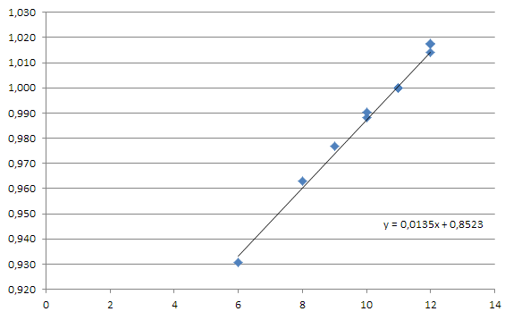

**Test 2 - Scenario 12C1 - Product 1 (EU, Nafta and Internet)**

Add to the same chart 2 extra points with commission changing for Internet market (line top).

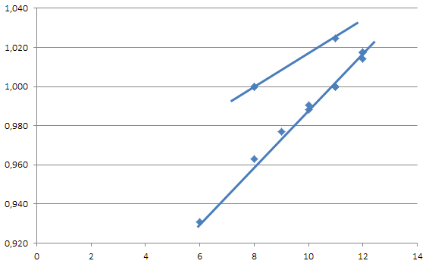

According to the results, we can say that influence of the commission on demand does not depend on product type, influence on products 1, 2 and 3 is the same. For EU and Nafta markets, influence of the commission is equal, for Internet market influence is weaker. Dependence on the change in demand is directly proportional to the commission and does not depend on influence of competitors in the group.

Maximum commission and support from current and previous period is taken when calculating payments to agents and distributors for sales. Optimal strategy will be to set a certain commission and support for each market in 1 period and not change until the end of the game.

**Test 3 - Scenario 12C3 - Product 1 (EU)**

Repeat the test on scenario 12C3. Chart shows the result of a change in commission on EU market in 1 period.

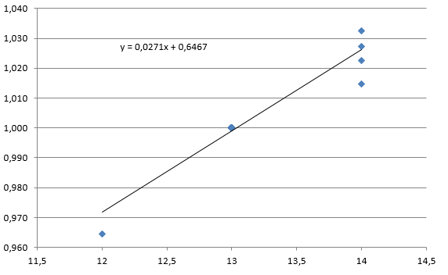

Result of commission's change in EU market in 2 period.

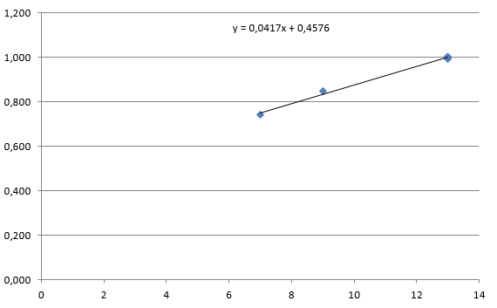

**Test 4 - Scenario 12C3 - Product 1 (Nafta)**

Result of commission's change in Nafta market in 1 period.

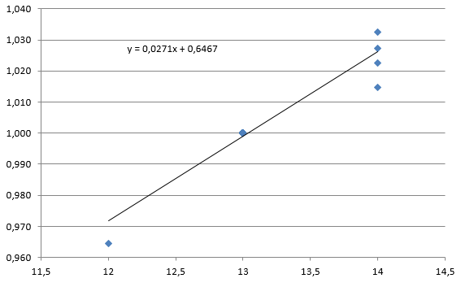

Result of commission's change in Nafta market in 2 period.

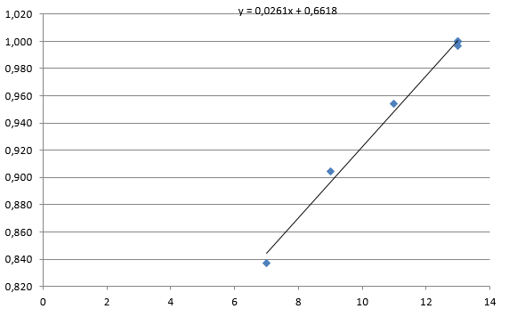

**Test 5 - Scenario 12C3 - Product 1 (Internet)**

Result of commission's change in Internet market in 1 period.

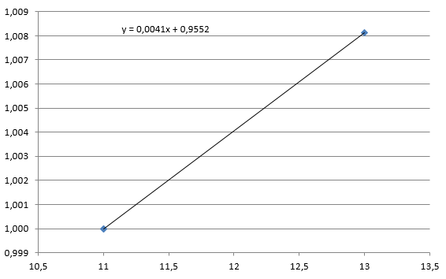

Result of commission's change in Internet market in 2 period

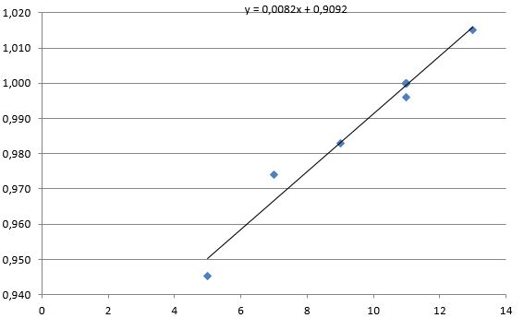

Relatively clean tests in the same groups for relevant comparison of results in 1 and 2 period is only for Nafta market. According to these data, commission of agents and distributors has a very small residual effect on demand, which can be neglected. Impact on demand for EU and Nafta markets is equal, as well as on previously tested scenario 12C1. Influence of the commission on demand in Internet market is less than in EU and Nafta markets.

*In previous version of GMC simulator, residual effect from the commission opposite was very high, which was often used by teams. In 5 period of the game, commission of agents and distributors usually reduced to a minimum value of 0.1% (whereas it was possible to specify fractional value). Demand with accumulated effect from commission in previous periods, was decreasing, but not critical and company earned additional profit by saving on deductions. After widespread such game strategy among teams, cumulative effect was significantly reduced.*

Since effect on EU and Nafta markets is significantly higher than in Internet market, commission for agents and distributors in EU and Nafta markets should be chosen higher than for Internet agent. Increasing deductions to agents and distributors will be justified by good increase in demand. On the contrary, a cost minimization strategy and game with minimum commission will be optimal for Internet agent, economic effect of reducing costs will exceed the decline in sales revenue due to a decrease in demand.

**Hints**

1．Cumulative effect is absent

2．Dependence is linear, does not depend on competitors in the group

3．Effect is equal for EU and Nafta markets, effect for Internet market is less

4．Effect is the same for all products

代理商和经销商佣金

代理商和分销商是全球管理挑战中最强大的需求因素之一。根据影响力，代理商和分销商几乎与价格一样强大。对需求的影响包括3个部分：

1．佣金

2．[数量](http://gmcworld.org/blog/agents-and-distributors-number)

3．[支持](http://gmcworld.org/blog/agents-and-distributors-support)费用

让我们看看佣金代理商和分销商的变化，需求如何变化。

**测试1 - 情景12C1 - 产品1（国内和北美）**

佣金代理人和经销商在第一期更换。 垂直－相对于国内和北美产品1的第五期历史报告的需求相对变化。 水平－佣金的绝对值。



**测试2 - 情景12C1 - 产品1（国内、北美和互联网）**

添加到相同的图表2额外点，互联网市场（线上）佣金更改。



根据结果可以看出，佣金对需求的影响不依赖于产品类型，对产品1，2和3的影响是一样的。 对于国内北美，佣金的影响是相等的，对于互联网市场的影响力较弱。对需求变化的依赖与佣金成正比，不依赖于竞争对手对小组的影响。

当向代理商和经销商支付销售费用时，将从当前和上一期起最高佣金和支持。最优策略将是在第一期内为每个市场设定一定的佣金和支持，直到游戏结束才能改变。

**测试3 - 情景12C3 - 产品1（国内）**

对方案12C3重复测试。 图表显示，第一期北美市场发生变化的结果。



国内市场在第二期内发生变化的结果。



**测试4 - 情景12C3 - 产品1（北美）**

北美市场在第一期内发生变化的结果。



北美市场在第二期内佣金变动的结果。



**测试5 - 情景12C3 - 产品1（互联网）**

互联网佣金在第一期内变化的市场结果。



佣金在第二期内互联网市场变化的结果



相同组别的相对干净的测试在1和2期间的结果进行相关比较只适用于北美市场。根据这些数据，代理商和分销商的佣金对需求的剩余效应非常小，这可以忽略不计。 对国内和北美的需求的影响是相等的，也是以前测试的情景12C1。佣金对互联网市场需求的影响低于国内和北美市场。

在以前版本的GMC模拟器中，对手的剩余效果非常高，这是球队经常使用的。在游戏的5个时期，代理商和分销商的佣金通常降至0.1％的最小值（尽管可以指定分数值）。以前期间佣金累计影响的需求下降，但并不重要，公司通过扣除扣除额度获得额外利润。队伍广泛的这种比赛策略之后，累积效应明显下降。

由于对国内和北美市场的影响明显高于互联网市场，国内和北美的代理商和分销商的佣金应高于互联网代理。 增加对代理商和分销商的扣除将因需求增加而被证明是合理的。相反，成本最小化策略和最小佣金的游戏对于互联网代理来说是最佳的，因为降低成本的经济效应将超过由于需求下降导致的销售收入的下降。

**提示**

1．累计效应不存在

2．线性依赖，不依赖于组内的竞争对手

3．国内和北美市场的影响效应相当，对互联网市场的影响较小

4．对所有产品的影响效果相同